Temasek Polytechnic
School of Informatics and IT

Diploma in Information Technology (IT)

Software Requirement Specifications (SRS)
Project Particulars
Tutor | Mr. Mel Goh
Class | P02
Project Title | Delonix Regia Hotel Management System

Project Team’s Particulars
Matric Number | Student Name
1500169F | Camille Pamela Anne S. Sioson
1502015I | Dixon Low Yi Sheng
1506381A | Raeburn Timothy Nigel
1502527C | Muhammad Nur Afnan Bin Abdul Rahim

Revision History

Date | Version | Description | Author
<24/5/17> | <1.1> | <Software requirement specifications for Mr. Wang’s management System> | <Camille,Afnan,Timothy, Dixon>

Table of Contents

1. DISTRIBUTION OF WORKLOAD 4
2. OVERVIEW OF REQUIREMENTS 4
2.1 System Functions 4
2.2 User Characteristics 5
2.3 General Constraints 6
2.4 Functional Requirements 6
2.5 Data Requirements 7
2.6 User Interface Requirements 8
2.7 Interface with Other Systems 9
2.8 Assumptions 9
3 OPERATIONAL AND QUALITY REQUIREMENTS 10
3.1 Operating Environment 10
3.2 Development Constraints 10
3.3 Performance 10
3.4 Availability 11
3.5 Security and Access Control Requirements 11
4 SPECIAL REQUIREMENTS 11

DISTRIBUTION OF WORKLOAD

Requirement Gathering | Members
- Operational and quality requirements  - Special requirements | Afnan and Timothy
- System functions  - Functional requirements  - Data requirements  - User interface requirements | Camille
- User characteristics  - General constraints  - Interface with other systems  - Assumptions | Dixon

OVERVIEW OF REQUIREMENTS

System Functions
There are 3 main functions of the systems that are to be implemented are:

Room availability and booking module
The function of this module is to allow the end users which are the reception staff to be able to check the availability of the rooms and to be able to book a room for the guest as well and having it to be stored in a database. This is because before this implementation, the checking of room availability and booking is done through email, hence it is done manually by the staff receptionist.
This function will be made accessible to the end users which are the receptionists, the management users, and hotel administrators. The functions that come along with this module is that the administrators have access to editing the guests’ information as and when is needed. For an example, amending the number of children staying in the room etc. also, there will be a check in and check out function as well. For the check-out function, the guests hand their room key to the receptionist and after which, the receptionist would ask the guest(s) if they have/had consumed for an example drinks from the mini bar. They will then key into the system and after which, will create an invoice receipt which contains the payment needed to be made for the room plus the additional consumption they have made in the room such as the mini bar or extra room services.

Housekeeping and staff management module
There are two key features/functions in this module. The staff management’s function is for the administrator to keep a record of the staff and their information such as Name, Date of Birth, Bank account number etc. and also the type of duties the staff can do. There are 4 duty types a staff can do and they are:
- General Maintenance
- Room Maintenance
- Estate Maintenance
- Security
The different staff has different duties hence it is required for them to state which duty one is taking on. Generally, the function of this module is to keep track of the staff and their assigned/designated duties and also to keep track of the housekeeping schedules so that all rooms will be scheduled for housekeeping when needed. This function is made accessible to management users and hotel administrators.

Reporting Module
There are 5 reports required in this reporting module. They are the following with their respective functions
- Room Status – This report will contain the list of rooms in the hotel with their corresponding room status which is either Vacant, Occupied or Vacant and has been scheduled for cleaning.
- Guests in a room – This report will contain the list of guests in a room. For an example, how many adults and children are occupying one king sized bedroom
- Guests in all rooms – This report will contain the lists of guests in all rooms at any given point of time. For an example, the list of guests on the 17th of January 2017.
- Room Occupancy – this report will generate statistics which will indicate what the room occupancy was on a daily, weekly, monthly or yearly basis. This is only accessible by the management users and administrators only.
- Housekeeping – This report allows the administrators to list the duties that the staff has been designated to. This report allows the user to generate the housekeeping schedules based on the daily, weekly or monthly basis. Similar to the room occupancy report, this is only made accessible to the management users and administrators only.
Other than having to be able to generate different reports, the additional feature of this function is that there will be a preview of reports before it is sent to be printed. By having this feature, it reduces the mistakes or errors that can occur for an example, printing the set of the report for 17th June instead of 18th June.
Other than the 3 main functions mentioned above, we are also implementing an additional function which is:
User Account and Login Creation Module
This function is for hotel administrator to create a new account for new staffs and new users of the system.

User Characteristics
There are three levels of users. End users, Management users, and Administrators
End users will be the reception staff at the counter. They can access parts of the reporting module, selected reports. They also need full access to room availability and booking module.
Next level is the management users. They have access to all three modules, which are room availability & booking, housekeeping & staff management and lastly, the reporting module.
The last level is the administration users. The administrator, Mr. Wang himself, will have access to all parts of the system, all three modules as mentioned in the management user role. In addition, administrator will have access to user account and login creation module, which only the administrator has. It allows for the creation of accounts for new staff and users.

General Constraints
Software will be installed in a single computer at the reception staff area. Old computer, Pantheon 4 PC running on Windows Support Package 2. It uses 1GB of RAM, has a 160GB hard disk and connected to the internet via a broadband connection. Therefore, the capacity and latency of the program has to be carefully monitored so the program can run smoothly at all times since an old computer with less ideal specifications will be used for installation of the software and only that computer will be the one which has the software installed. The low RAM capacity means that too much memory cannot be used at one time otherwise the software might lag.
Another general constraint is that the budget of system is $70,000 and 2 weeks are given to complete project.

Functional Requirements
As mentioned in 2.1, there are 4 modules in which will be implemented in the system. I will be explaining the function requirements of the what the system should do accordingly, in different modules.

Room Availability and Booking module
The system shall allow the search of room availability by dates given or specified. It should display to the end users whether is currently vacant, booked or occupied. The system shall also allow the end users to book a room by using the guests’ details such as name, mailing address, payment mode etc. When searching for room availability, the system shall allow the system to search available rooms based on the size/type of the room, for an example luxury room which has king-sized beds. The system shall allow the end users to amend the guests’ information after the confirmation of the booking. For an example, amending the number of guests in the room booked (2 adults, 3 children). The system shall allow remarks to be made per the guests, for an example, additional bed for the room. The system shall allow the end users to check-out the guests and help create an invoice that includes payment for the room booked and the extra items that they have used or requested.

Housekeeping and staff management module
The system shall allow to search a staff using their corresponding staff ID and it should display the information of the staff, including the duty he/she is rostered in. The system shall allow the hotel administrator to edit the staff details at any given point of time. The system shall allow for the administrator to view the rooms and its schedule for housekeeping.
Reporting modules
The system shall display the 5 reports as and when it is requested. For room occupancy report, the system shall allow the report to be either daily, weekly, monthly or yearly basis report. For housekeeping report, the system shall generate housekeeping schedules based on daily, weekly, monthly schedules. For room occupancy and housekeeping report, the system shall only make this accessible to the hotel administrators and management users via their ID and password.
User Account and Login creation module
The system shall allow the hotel administrator to be able to create, update and delete a user account and as well as login.

Data Requirements
In this section, the data requirements will be addressed per its module. This is so it will be simpler and easier to comprehend.

Room Availability and Booking module
For this module, the data requirements are the details of the guest and as well as the details of the room booking. For the guest, details that are stored within the system are first name, last name, Date of birth, contact number, email, the chosen check-in and check-out date, payment method. For the room booking details, what should be captured, or rather what is stored is the room number, floor number, remarks such as the details of the room itself. For an example, if the room consists of a king-sized bed etc. as mentioned, payment method is also stored within the system and this payment method has details that come along with it. Such are the card name, expiry date, card number.

Housekeeping and staff management module
For this module, the data requirements are as follows:
Staff ID, staff name, bank account number, contact number, and the staff role. As mentioned there are 4 duties. Therefore, duty name and duty ID is stored within the system. For the housekeeping, such details are needed – the room of which the housekeeping has been scheduled, the time scheduled for housekeeping to be done in the specific room. And, who is assigned to do the housekeeping.

Reporting module
For this module, it needs the most data requirement as these reports generate the statistics based on the data. The data requirements are the list of the hotel rooms in the hotel, the rooms that are vacant, occupied or vacant and has been scheduled for housekeeping, the list of guests in a specified room, guests of the hotel at a given point of time, the staff and the list of duties that have been assigned to them and the housekeeping schedules of the rooms.

User Account and Login creation module
For this module, the data requirements are like the staff management because this module creates new users which in most cases are newly-hired staff. So, for this module, the data requirements are as such – staff name, staff ID, bank account number, contact number. Since there is a login creation module, password will be required as well. Their username will be the staff ID that is corresponding to them. This way, it will be easier to track if there will be a need to.

User Interface Requirements
End Users (Receptionist)
Given a scenario that the receptionist has to book a room for a walk-in guest.

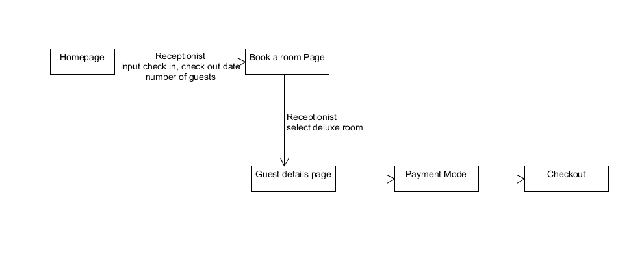

Management users
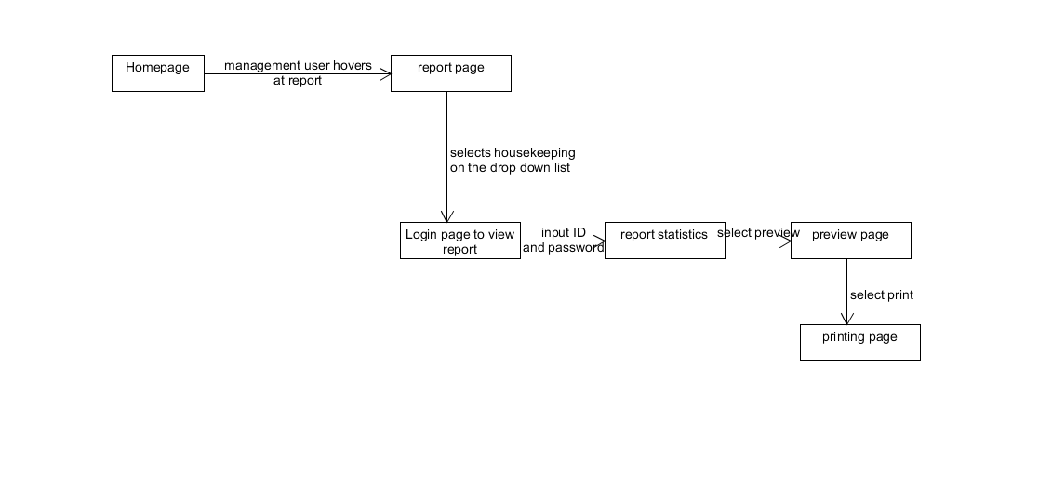
Given a scenario that the management user want to view the housekeeping report. He also wants a preview before printing the report.

Hotel Administrators
Given a scenario that the administrator want to create a new staff account

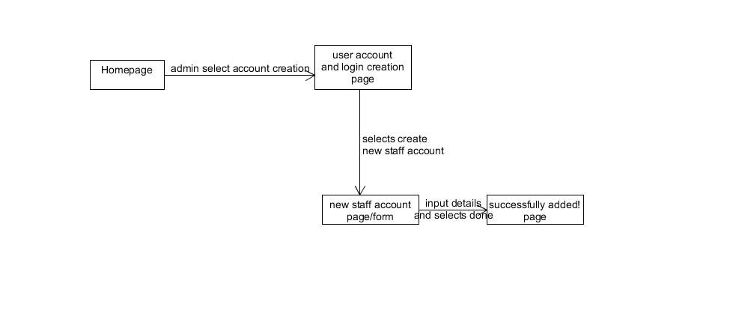

These user interface diagrams are just some of the scenarios in which each level of user will do. With this user interface diagrams, it helped to plan out the different pages needed, so that all actions will be addressed and all actions would have a corresponding page.

Interface with Other Systems
Given limited budget and limited development time, Mr Wang does not need the system to be integrated with other kinds of existing system.

For long term, additional feature could be implemented for guests to enquire of room availability online entirely. Currently, guests send an email to Mr Wang then he has to manually check the system to see what rooms are available then he would reply back through email. Basically, what Mr Wang wants is to make the process automated by having a feature to allow guests to check room availability without having to go through him and having to wait for his reply, making the process much smoother and quicker.

Another feature, also for long term, is to have the data in the five reports in the reporting module to be able to be exported into Excel spreadsheets so that Mr Wang has numerical figures to do his spreadsheets.

Assumptions
We assume features for the long term to not be on the priority list. We assume we are allowed to use any database software, any software to create the software as long as it is within the budget of $70,000. We also assume that interface with other systems is necessary since Mr Wang did not mention. For example, the staff management system with the room availability and booking system.

OPERATIONAL AND QUALITY REQUIREMENTS

Operating Environment
Mr Wang - Single computer at the reception staff area only place the software will be installed
Computer - Pentium 4 pc running on Windows 7 enterprise (32bit).
Monitor - resolution of 1024x768, keyboard and mouse
Ram - 4GB
Hard disk - NTFS file-system formatted with size of 160GB
Printer that will be printing the report module.
Internet - Connected via broadband connection that he uses to maintain the hotel website
Software:
-Microsoft SQL Server Management Studio Express 2010
-Microsoft .Net Framework 4.0

Development Constraints
Constraints such as the compatibility with the hotel’s current software system. The application must be able support the proposed Windows 7 enterprise computer. In order to ensure that the system is reliable, some design and implementation constraints are applied. Other constraints such as limited memory and processing power are also worth considering. Hotel management system is meant to be quick and responsive, even when dealing with huge amount of bookings and transactions, so each feature must be designed and implemented with efficiency in mind. The application may lack scalability and increasing more PC may hinder the performance of the application. There is also availability of an android app for the hotel management system that is able to allow the system to be portable but due to the limited time that is given for the development of the application. Another constraint is the overall budget given by Mr Wang to develop this system.

Performance
The performance of the system is mainly dependent on the performance of the hardware and software components of the installing computer. The system should be able to automate processes such as room booking. The system should also able to handle multiple bookings of rooms at a time. The load time for the user interface of the application should not take more than two second. The logging in of the user’s information should be within five seconds. The data that will be updated in the database should be updated within two seconds. Queries shall return the result within five seconds. Customer inquiry should also be responded within five minutes.

Availability
In a Hotel business hotel are operating 24 by 7 every year. The system is required to also run 24 by 7. For data backup the acceptable time would be around 2 - 3 am and the acceptable downtime for maintenance would be around 4 - 5 am during the non peak hours. Once a month during the first sunday of every month Mr Wang would like the backup record to be kept in the system for 5 years.

Security and Access Control Requirements
The owner will have the maximum privileges of access to all the subsystems. The Guest Service Representative is granted access to the reservation or booking of the room, food accommodation and also the room accommodation. The managers will have access to the management subsystem and the reservation or booking of the room, food accommodation and also the room accommodation. A login page which requires username and password will ensure that only authorized users are able to gain access to various subsystem.

Security of the communication between the system and server. All the external interaction between the data’s server and the client must be encrypted. The messages should be encrypted for log-in communications, so others cannot get user-name and password from those messages

SPECIAL REQUIREMENTS

For room availability, Mr Wang and reception staff should be able to edit guests record such as the changes of room if guests are not satisfied with the room. For example, if there are three additional guests staying over when the customer first arrives at the hotel.
For reporting module to allow Mr Wang to export it to excel before printing so that he is able to edit and preview.

Having a data archival feature which will store the old data into the archive. This allow the hotel to review the important data which will help them make better decisions. It also ensures the data integrity when archived data regularly. Clearing the storage of the database will also help remove errors of some data.

